Definition of the Selectet Segments Pane
Menu Bar
Toolbar
Defined Segments Pane
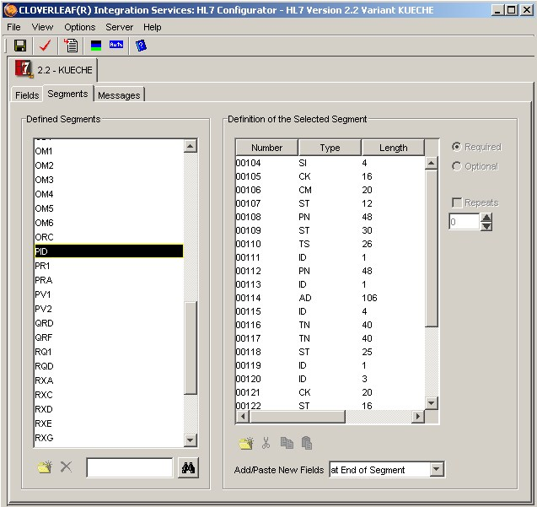
New
Delete
Find
Add Cut Copy Paste Position

